THIS SECTION IS THE TITLE AREA – WRITE THE TITLE USING AN INVERTED PYRAMID STYLE (THE TOP
Document settings such as margins, styles, and so on should be taken directly from this template. Do not create them from a new file.
LINE IS LONGER THAN THE BOTTOM LINE)
Between the title and the logo, there is the text ‘TITLE PAGE’ written in white. The purpose of this is to ensure that it appears in the table of contents.

TITLE PAGE



Conduct by:

Name  Student ID  The title and the name of each student will be different. Make sure to arrange them properly to maintain a neat layout. | : Informatika  : 94523999

PROGRAM STUDI INFORMATIKA – PROGRAM SARJANA
FAKULTAS TEKNOLOGI INDUSTRI
UNIVERSITAS ISLAM INDONESIA
2020

SUPERVISOR ENDORSEMENT PAGE

THIS SECTION IS THE TITLE AREA – WRITE THE TITLE USING AN INVERTED PYRAMID STYLE (THE TOP
LINE IS LONGER THAN THE BOTTOM LINE)


THESIS

Conduct By:

Name  Student ID | : Informatika  : 94523999
The title and the name of each student will be different. Make sure to arrange them properly to maintain a neat layout.

Replace the dates and names in this template with the actual dates and names.

Yogyakarta, July 18st, 2025
Advisor,

( Zainudin Zukhri, S.T, M.IT )

EXAMINER ENDORSEMENT PAGE

THIS SECTION IS THE TITLE AREA – WRITE THE TITLE USING AN INVERTED PYRAMID STYLE (THE TOP
LINE IS LONGER THAN THE BOTTOM LINE)

THESIS

Has been defended in front of the examiners as one of the requirements to obtain a Bachelor of Informatics degree from the Undergraduate Program in Informatics at the Faculty of Industrial Technology, Universitas Islam Indonesia
Yogyakarta, July 18st, 2025

Chair | _______________________
Hendrik, S.T., M.Eng. | _______________________
Examiner 1 | _______________________
Dr. Raden Teduh Dirgahayu, S.T., M.Sc. | _______________________
Examiner 2 | _______________________
Dr. Mukhammad A Setiawan, S.T., M.Sc. | _______________________

Acknowledged by,
Head of Undergraduate Program in Informatics
Faculty of Industrial Technology
Universitas Islam Indonesia

( Ir. Dhomas Hatta Fudholi, S.T., M.Eng., Ph.D. )

AUTHENTICITY STATEMENT

The undersigned:
Name : Informatika
Student ID : 94523999

Final project with title:
THIS SECTION IS THE TITLE AREA – WRITE THE TITLE USING AN INVERTED PYRAMID STYLE (THE TOP
LINE IS LONGER THAN THE BOTTOM LINE)

Stating that all components and contents in this final project are my own work. If in the future it is proven that some parts of this work are not my own work, the final project submitted as my own work is ready to be withdrawn and ready to bear any risks and consequences.
Thus this statement letter is made, hopefully it can be used properly.

Yogyakarta, July 18st, 2025
This statement must be signed on a revenue stamp (Indonesian fiscal stamp used for legal documents, commonly referred to as materai).

( Student’s Name )

DEDICATION

This section may be freely written with any form of dedication as long as it does not violate ethics. Ideally, this page should consist of one full page.

MOTTO

This section may be freely written with any form of motto as long as it does not violate ethics. Ideally, this page should consist of one full page.

FOREWORD

The foreword is the section used to express gratitude for the completion of the final project report. It may also include:
- The purpose of writing the report or conducting the research.
- Non-academic difficulties encountered during the research.
- Acknowledgements to those who helped or supported the completion of the report or research.
- The author’s expectations regarding the completed research.
The foreword is usually closed with the author’s signature.

Yogyakarta, July 18st, 2025

( Student’s Name )

ABSTRACT

The abstract is a section of the report containing the main ideas, including the background, a brief overview of the research, the methodology used, and the findings collected from the research. Ideally, the abstract should be one page long, with several keywords added.

Keywords: abstract, methodology, findings.

GLOSSARY

The glossary contains specific terms used in the report that require explanation, such as uncommon borrowed terms. Arrange the terms alphabetically. Example:

Compile the process of converting program code files together with related files into files ready to be executed by the operating system.
Debug the process of tracing errors in program code.
Waterfall a method of software development.

TABLE OF CONTENTS
The table of contents will adjust automatically to the content of your thesis, including the page numbers.
Once the editing process is considered complete, this page must be updated (right-click -> Update).
After the update, the layout of this page may become untidy, so do not forget to tidy it up again.

TITLE PAGE i
SUPERVISOR ENDORSEMENT PAGE ii
EXAMINER ENDORSEMENT PAGE iii
AUTHENTICITY STATEMENT iv
DEDICATION v
MOTTO vi
FOREWORD vii
ABSTRACT viii
GLOSSARY ix
TABLE OF CONTENTS x
LIST OF TABEL xi
LIST OF FIGURES xii
CHAPTER I WRITE THE CHAPTER TITLE ON THIS LINE 1
1.1 Subchapter 1
1.1.1 Sub-subchapter 1
1.1.2 Sub-subchapter 1
1.2 Subchapter 1
1.3 Subchapter 2
1.4 Subchapter 2
CHAPTER II WRITE THE CHAPTER TITLE ON THIS LINE 3
2.1 Subchapter 3
2.2 Subchapter 3
CHAPTER III WRITE THE CHAPTER TITLE ON THIS LINE 6
3.1 Subchapter 6
3.2 Subchapter 6
3.3 Subchapter 6
CHAPTER IV WRITE THE CHAPTER TITLE ON THIS LINE 7
4.1 Subchapter 7
4.2 Subchapter 7
4.3 Subchapter 7
CHAPTER V WRITE THE CHAPTER TITLE ON THIS LINE 8
5.1 Subchapter 8
5.2 Subchapter 8
5.3 Subchapter 8
CHAPTER VI WRITE THE CHAPTER TITLE ON THIS LINE 9
6.1 Subchapter 9
6.2 Subchapter 9
6.3 Subchapter 9
REFERENCE 10
APPENDIX 11

LIST OF TABEL

Table 2.1 Example of a table created using MS Word 4
Table 2.2 Example of a table created using MS Excel 4

LIST OF FIGURES

Figure 2.1 Copy-paste method for creating figure titles 3
Figure 2.2 How to copy-paste equation ( 3.1 ) into equation ( 2.1 ) 5
Figure 3.1 Example of program code considered as a figure. 6

CHAPTER I
WRITE THE CHAPTER TITLE ON THIS LINE
To move to a new line, use the [Shift] + [Enter] key combination. If you only press [Enter], the text ‘CHAPTER ..’ and its title will be separated into two lines. Remember: in the table of contents, the chapter and its title must be on the same line.
If a number appears before the text ‘CHAPTER ..’, you can hide it by placing the cursor before the word ‘CHAPTER’, then quickly pressing the left arrow key three times.
Do not delete it manually, because deleting the number before the word ‘CHAPTER’ manually will cause the chapter numbering to be entered manually as well.

Subchapter
Paragraph formatting with the paragraph style is applied consistently throughout the document. The first line is indented 1 cm from the left margin with justified alignment, followed by the next lines aligned with the left margin. Subchapters are numbered using two digits.
If there is only one Sub-subsection under a Subsection, the discussion should not be written as a Sub-subsection. Instead, continue it as a paragraph within the Subsection. A Sub-subsection should only be written separately if there are at least two Sub-subsections.

Sub-subchapter
Sub-subchapters are numbered using three digits. After sub-subchapters, numbering should use uppercase alphabet letters in bold.

Sub-sub-subchapter
Sub-sub-subchapters do not need numbering but should be in bold. Sub-sub-subchapters do not need numbering but should be in bold. Sub-sub-subchapters do not need numbering but should be in bold.

Sub-subchapter
Sub-subchapters are numbered using three digits. After sub-subchapters, numbering should use uppercase alphabet letters in bold.

Subchapter
For level 1 numbering, use lowercase alphabet letters. The numbering starts from the left margin, as shown below:
- If there is another level inside level 1 (level 2 numbering), use Arabic numerals, with numbering positioned 0.8 cm from the left margin, as follows:
- Level 2 numbering.
- Level 2 numbering.
- Level 2 numbering.
If there is another level inside level 2 (level 3 numbering), explain them one by one as follows: level 3 numbering, level 3 numbering, level 3 numbering.
- If there is another level inside level 1 (level 2 numbering), use lowercase alphabet letters with parentheses. The numbering is positioned 0.8 cm from the left margin.
- If there is another level inside level 1 (level 2 numbering), use lowercase alphabet letters with parentheses. The numbering is positioned 0.8 cm from the left margin.

Subchapter
Paragraph formatting with the paragraph style is applied consistently throughout the document. The first line is indented 1 cm from the left margin with justified alignment, followed by the next lines aligned with the left margin.

Subchapter
Paragraph formatting with the paragraph style is applied consistently throughout the document. The first line is indented 1 cm from the left margin with justified alignment, followed by the next lines aligned with the left margin.

CHAPTER II
WRITE THE CHAPTER TITLE ON THIS LINE
To move to a new line, use the [Shift] + [Enter] key combination. If you only press [Enter], the text ‘CHAPTER ..’ and its title will be separated into two lines. Remember: in the table of contents, the chapter and its title must be on the same line.

If a number appears before the text ‘CHAPTER ..’, you can hide it by placing the cursor before the word ‘CHAPTER’, then quickly pressing the left arrow key three times.
Do not delete it manually, because deleting the number before the word ‘CHAPTER’ manually will cause the chapter numbering to be entered manually as well.

Subchapter
When referring to figures, do not use the phrase ‘as shown in the following figure’ but use the Reference menu, then click the Cross-reference icon, and select as shown in Figure 2.1. In the Reference type, Insert reference to, and For which caption sections, select according to your needs. Use the same method for tables. If in the Reference type options the choices ‘Figure’, ‘Table’, or equation ‘(’ do not appear, press the Cancel button and enter the Reference type from the Insert Caption icon.

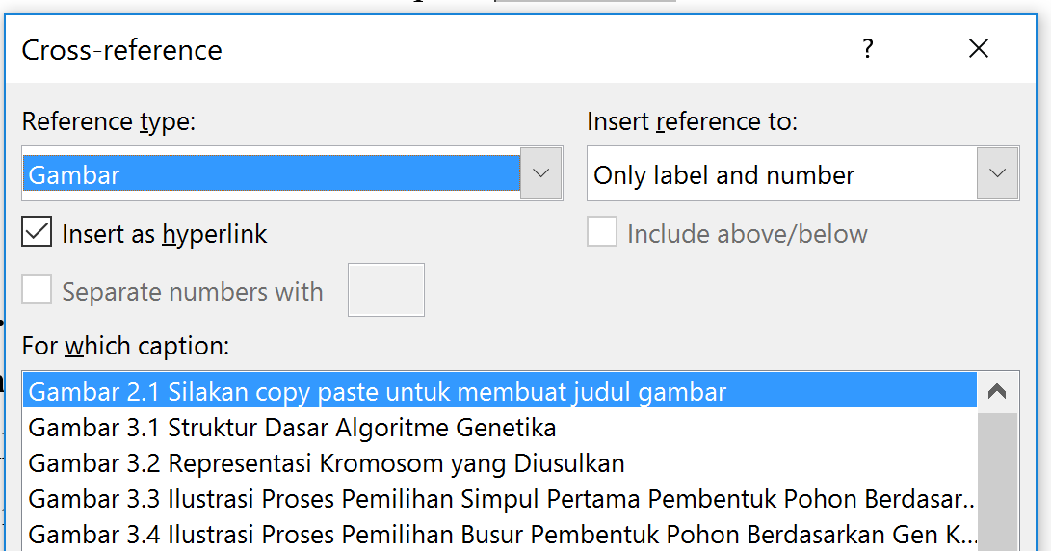
Use the APA style when inserting citations as shown in the example below the figure.
DO NOT WRITE FULL NAMES OR THE TITLE OF A BOOK/PAPER/RESEARCH IN THE MANUSCRIPT.
Figure 2.1 Copy-paste method for creating figure titles
Source: Zukhri (2014)
The title of the figure is placed in the center of the page, using normal font and not bold.

It is expected that with Figure 2.1 above, students can write their thesis quickly, because the list of figures can be updated automatically, adjusting both the numbering and actual page. Therefore, there is no need to create manual numbering or a list of figures. The same applies to tables.

Subchapter
To refer to a table, do not use the phrase ‘as in the following table’ but instead use the Reference menu, then click the Cross-reference icon and select as shown in Figure 2.1. In the Reference type, Insert reference to:, and For which caption sections, choose according to your needs. Tables will be easier to edit if created as a Microsoft Excel object. To create it, simply copy the table below. The advantage is that if the data in the table is connected to a chart/graph, then the chart will be linked to the data, so that every change in the data will automatically update the chart. It is expected that with Figure 2.1 above, students can prepare their thesis quickly, because later the list of figures only needs to be updated and it will adjust automatically with the figure and its actual page number. Therefore, there is no need to manually create numbering and a list of figures.
An example of a table can be seen in Table 2.1. To edit the table, simply right-click and choose open or edit. The fonts that can be used are Times New Roman with a minimum size of 11, or Courier New with a minimum size of 9, each with single spacing. The column titles should be centered within the column, while the data position should be aligned left for text or aligned right for numbers.

Table 2.1 Example of a table created using MS Word
Column 1 | Column 2 | Column 3
Testing | Testing | Testing
Testing | Testing | Testing
Testing | Testing | Testing

Pembuatan tabel menggunakan MS Word belum tentu mencukupi untuk manyajikan formula, maka tabel dapat dibuat sebagai objek MS Excel. Dalam penggunaan tabel dalam bentuk objek MS Excel, ukuran font harus dibuat proporsional dengan font yang digunakan dalam tabel MS Word sebagaimana contoh pada Table 2.2.

Table 2.2 Example of a table created using MS Excel
The title of the table is placed in the center of the page, using normal font and not bold.
Source: Use the References menu and adjust as needed so that the bibliography will automatically appear and can be easily cited here.

How to copy-paste an equation can be seen in Figure 2.2. The equation numbering will automatically adjust to the chapter number and the sequence within the related chapter. Do not create it manually. The numbers can also be referenced in the same way as figure and table numbers, so it is guaranteed that the references will not be incorrect.

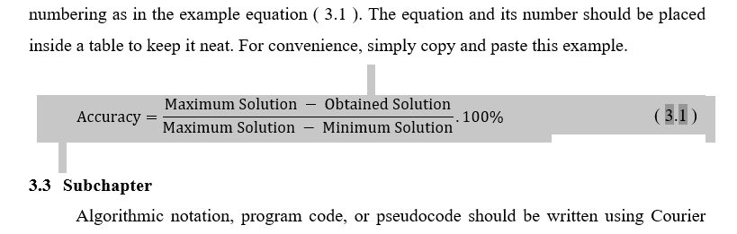
Figure 2.2 How to copy-paste equation ( 3.1 ) into equation ( 2.1 )

How the equation copied from Chapter 3 automatically adjusts its numbering can be seen in equation ( 2.1 ).

$$Accuracy=\frac{Maximum Solution - Obtained Solution}{Maximum Solution - Minimum Solution}.100\%$$ | ( 2.1 )
Equations must be written using the Equation feature and must not contain programming syntax elements (for example, multiplication should be written with a dot instead of an asterisk).
Each equation must be numbered, with the number placed at the right margin.

CHAPTER III
WRITE THE CHAPTER TITLE ON THIS LINE
To move to a new line, use the [Shift] + [Enter] key combination. If you only press [Enter], the text ‘CHAPTER ..’ and its title will be separated into two lines. Remember: in the table of contents, the chapter and its title must be on the same line.

If a number appears before the text ‘CHAPTER ..’, you can hide it by placing the cursor before the word ‘CHAPTER’, then quickly pressing the left arrow key three times.
Do not delete it manually, because deleting the number before the word ‘CHAPTER’ manually will cause the chapter numbering to be entered manually as well.

Subchapter
The paragraph format with the paragraph content style is applied consistently throughout the entire document. The first line is indented 1 cm from the left margin with justified alignment, followed by the next lines starting from the left margin.

Subchapter
To create an equation, use the Insert menu and the Equation icon, and provide equation numbering as in the example equation ( 3.1 ). The equation and its number should be placed inside a table to keep it neat. For convenience, simply copy and paste this example.

$$Accuracy=\frac{Maximum Solution - Obtained Solution}{Maximum Solution - Minimum Solution}.100\%$$ | ( 3.1 )

Subchapter
Algorithmic notation, program code, or pseudocode should be written using Courier New font or a similar font (size 9, single spacing) and considered as a figure, as shown in Figure 3.1.
Algorithmic notation or program code must be enclosed within a border. The code must be taken directly from a text editor and not from a screenshot.
#include <iostream>
using namespace std;
int main()
{
cout << "Hello world!" << endl;
return 0;
}
Figure 3.1 Example of program code considered as a figure.

CHAPTER IV
WRITE THE CHAPTER TITLE ON THIS LINE
To move to a new line, use the [Shift] + [Enter] key combination. If you only press [Enter], the text ‘CHAPTER ..’ and its title will be separated into two lines. Remember: in the table of contents, the chapter and its title must be on the same line.

If a number appears before the text ‘CHAPTER ..’, you can hide it by placing the cursor before the word ‘CHAPTER’, then quickly pressing the left arrow key three times.
Do not delete it manually, because deleting the number before the word ‘CHAPTER’ manually will cause the chapter numbering to be entered manually as well.

Subchapter
The paragraph format with the paragraph content style is applied consistently throughout the entire document. The first line is indented 1 cm from the left margin with justified alignment, followed by the next lines starting from the left margin.

Subchapter
The paragraph format with the paragraph content style is applied consistently throughout the entire document. The first line is indented 1 cm from the left margin with justified alignment, followed by the next lines starting from the left margin.

Subchapter
The paragraph format with the paragraph content style is applied consistently throughout the entire document. The first line is indented 1 cm from the left margin with justified alignment, followed by the next lines starting from the left margin.

CHAPTER V
WRITE THE CHAPTER TITLE ON THIS LINE
To move to a new line, use the [Shift] + [Enter] key combination. If you only press [Enter], the text ‘CHAPTER ..’ and its title will be separated into two lines. Remember: in the table of contents, the chapter and its title must be on the same line.

If a number appears before the text ‘CHAPTER ..’, you can hide it by placing the cursor before the word ‘CHAPTER’, then quickly pressing the left arrow key three times.
Do not delete it manually, because deleting the number before the word ‘CHAPTER’ manually will cause the chapter numbering to be entered manually as well.

Subchapter
The paragraph format with the paragraph content style is applied consistently throughout the entire document. The first line is indented 1 cm from the left margin with justified alignment, followed by the next lines starting from the left margin.

Subchapter
The paragraph format with the paragraph content style is applied consistently throughout the entire document. The first line is indented 1 cm from the left margin with justified alignment, followed by the next lines starting from the left margin.

Subchapter
The paragraph format with the paragraph content style is applied consistently throughout the entire document. The first line is indented 1 cm from the left margin with justified alignment, followed by the next lines starting from the left margin.

CHAPTER VI
WRITE THE CHAPTER TITLE ON THIS LINE
To move to a new line, use the [Shift] + [Enter] key combination. If you only press [Enter], the text ‘CHAPTER ..’ and its title will be separated into two lines. Remember: in the table of contents, the chapter and its title must be on the same line.

If a number appears before the text ‘CHAPTER ..’, you can hide it by placing the cursor before the word ‘CHAPTER’, then quickly pressing the left arrow key three times.
Do not delete it manually, because deleting the number before the word ‘CHAPTER’ manually will cause the chapter numbering to be entered manually as well.

Subchapter
The paragraph format with the paragraph content style is applied consistently throughout the entire document. The first line is indented 1 cm from the left margin with justified alignment, followed by the next lines starting from the left margin.

Subchapter
The paragraph format with the paragraph content style is applied consistently throughout the entire document. The first line is indented 1 cm from the left margin with justified alignment, followed by the next lines starting from the left margin.

Subchapter
The paragraph format with the paragraph content style is applied consistently throughout the entire document. The first line is indented 1 cm from the left margin with justified alignment, followed by the next lines starting from the left margin.

REFERENCE
If a number appears before the title "REFERENCES," to hide it place the cursor before the word "REFERENCES," then quickly press the left arrow key three times.

Use a reference manager such as Mendeley, Qiqqa, Zotero, DocEar, or the References feature in MS Word to prepare the Reference List. Do not forget to use the APA 6th edition format. With these features or software, the reference list will automatically be arranged alphabetically and can be easily cited within the text. An example of writing in APA format can be seen below.

Hendrik, Anjomshooa, A., & Tjoa, A. M. (2014). Towards Semantic Mashup Tools For Big Data Analysis. Proceding of the Information & Communication Technology-EurAsia Conference 2014, (pp. 100-145). Bali.
Setiawan, A. M. (2013). Integrated Framework For Business Process Complexity Analysis. Retrieved from ECIS 2013 Completed Research: http://aisel.aisnet.org/ecis2013_cr/49
Taufiq, H. (2015). Argumentasi dan Validitas. Yogyakarta: Darqin.
Wahid, F. (2014). The Antecedents And Impacts of a Green Eprocurement Infrastructure: Evidence From The Indonesian Public Sector. International Journal of internet Protocol Technology, 7(4), 210-218.
Zukhri, Z. (2014). Algoritma Genetika: Metode Komputasi Evolusioner untuk Menyelesaikan Masalah Optimasi. Yogyakarta: Andi Publisher.

The list above is only an example and may not correspond to actual published works. In the actual thesis, every item included in the reference list must be cited in the text (use the Insert Citation menu to simplify the process and ensure synchronization between in-text citations and the reference list).

APPENDIX

Appendices do not need to be given page numbers. Any documents included in the appendices should simply be given a title with the word APPENDIX followed by uppercase letters for numbering. Only the title APPENDICES should be included in the table of contents. Appendix titles, such as Appendix A, Appendix B, and so on, do not need to be included in the table of contents.

